Manual Guide

A guide to edit the Responsive image sliders on my website by using jQuery library and CSS3



**Topic:** jQuery (Lightbox Slider) / CSS3  
**Difficulty:** Intermediate

Sachin Gumber

s214793

Today we will code a responsive image slider from the Impressionist UI. We will code it using the JQ library for the functionality and style is using CSS3. I hope you will enjoy it and find it easy to edit it as per your own requirements.

The source code library

The image slider uses the jQuery UI library. You can download the ZIP of the latest release from the Github Releases or [www.jQuery.com](http://www.jQuery.com)

1. Add below codes to the website inside the header part of your website after downloading the library to the local folder of your pc.

<script src="js/jquery-3.5.1.min.js"></script>

<script src="js/jquery-ui.js"></script>

<script src="js/slider.js"></script>

<script src="js/lightbox.min.js"></script>

Please note that jQuery library or slider library name could be changed depend on the version you are installing.

1. Include the Lightbox CSS and JavaScript. You can grab both files from / dist folders.

Include the CSS at the top of your page in Your <head>Tag.

<link rel="stylesheet" type="text/css" href="css/lightbox.min.css">

<link rel="stylesheet" type="text/css" href="css/lightbox.css">

<link rel="stylesheet" type="text/css" href="css/styles.css">

Include the JavaScript at the bottom of your page before the closing </body> tag.

<script src="js/lightbox.js"></script>

1. Make sure all the jQuery, which is required by Lightbox, is also loaded.

If you are using any jQuery to support your lightbox then it is loaded before the lightbox.js.

HOW TO EDIT IMAGE SLIDER

Step 1:

**Prepare the images:**

You can change the images or add it by adding code to the below.

The image size must be 1000px width and 300 height.

The file type need to be .jpg, .png, .gif.



Copy all the images to website in the images folder.

Step-2-

Edit the slider

To add the images, add another <div class= “gallery “></div> and inside this another image file as shown in the below picture.

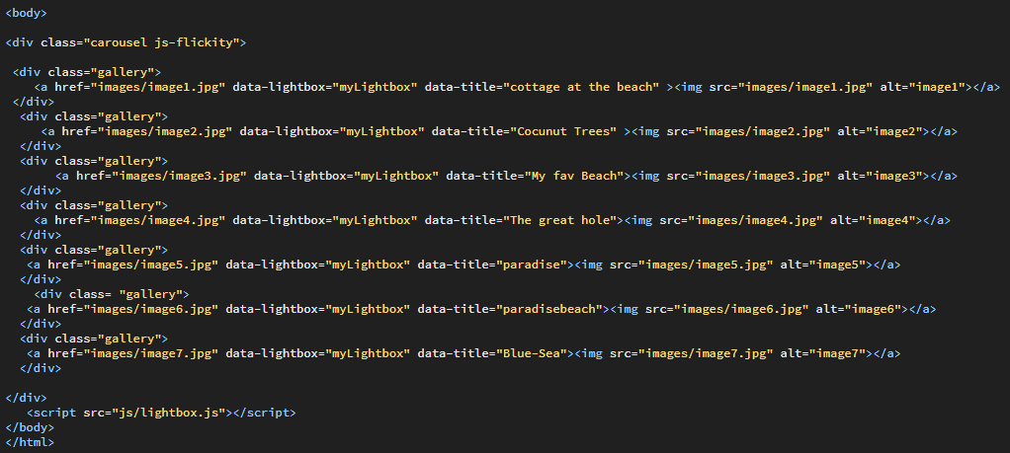

Inside casousel js-flickity div class.

* You can change the image src name of the slides.
* If you want to add more slides, you just duplicate the code inside the div class <div class= “gallery “>….</div>

To control the previous or next button go through the CSS and modify the “ .flickity-prev-next-button” class.